**PIZZA SALES DATA ANALYSIS BY SQL QUERIES**

**About Dataset**

**Contents**

This pizza sales dataset makes up 12 relevant features:

* order_id: Unique identifier for each order placed by a table
* order_details_id: Unique identifier for each pizza placed within each order (pizzas of the same type and size are kept in the same row, and the quantity increases)
* pizza_id: Unique key identifier that ties the pizza ordered to its details, like size and price
* quantity: Quantity ordered for each pizza of the same type and size
* order_date: Date the order was placed (entered into the system prior to cooking & serving)
* order_time: Time the order was placed (entered into the system prior to cooking & serving)
* unit_price: Price of the pizza in USD
* total_price: unit_price * quantity
* pizza_size: Size of the pizza (Small, Medium, Large, X Large, or XX Large)
* pizza_type: Unique key identifier that ties the pizza ordered to its details, like size and price
* pizza_ingredients: ingredients used in the pizza as shown in the menu (they all include Mozzarella Cheese, even if not specified; and they all include Tomato Sauce, unless another sauce is specified)
* pizza_name: Name of the pizza as shown in the menu

1. **Snapchat of Data Set**

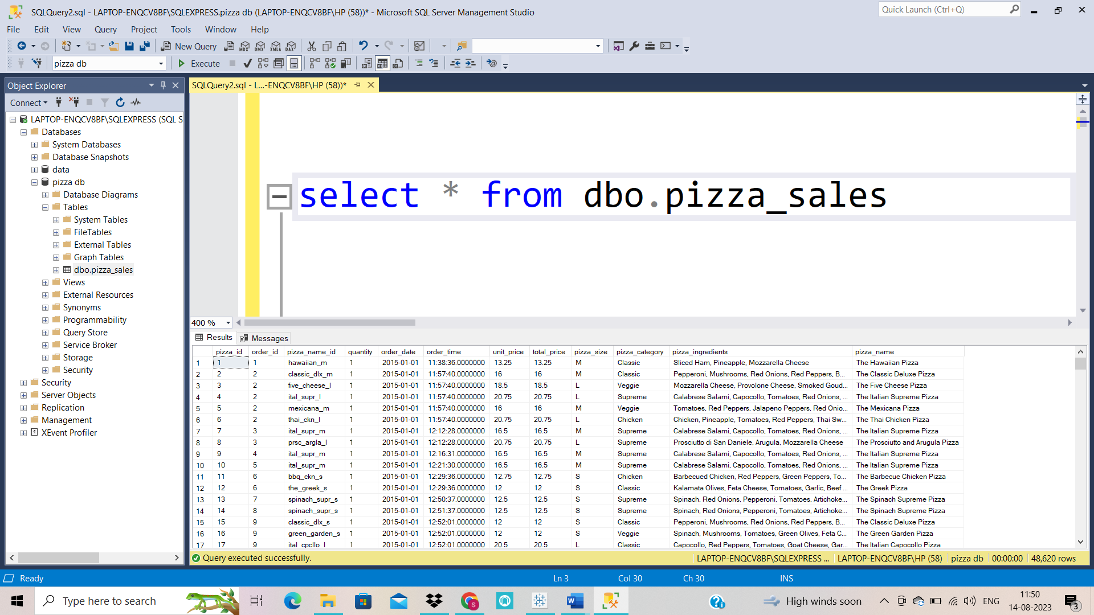

1. **KPIs**
   1. 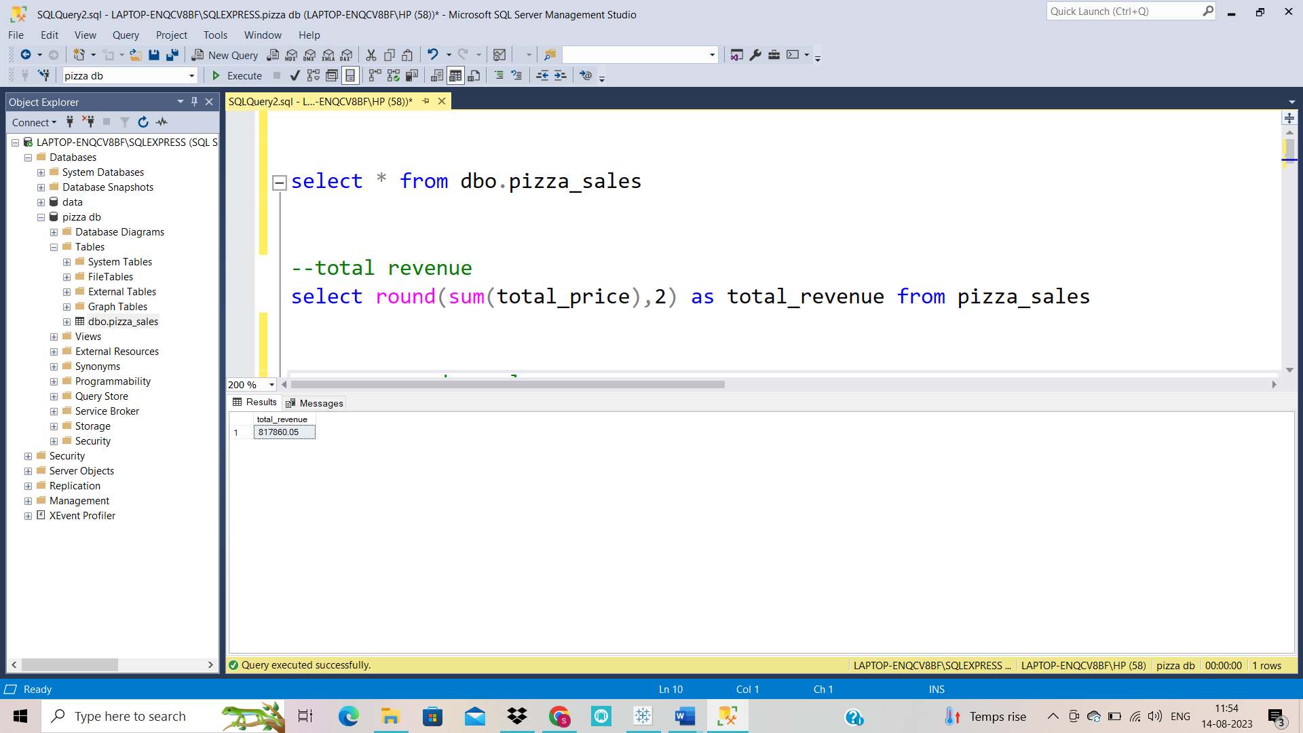**Total Revenue:**

* 1. **AVERAGE ORDER VALUE**

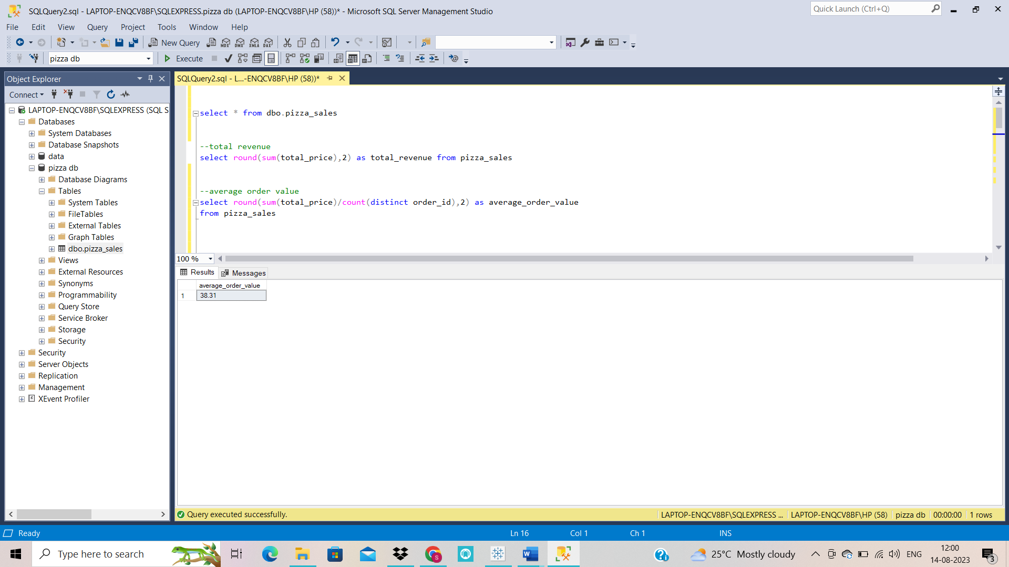

* 1. **Total Pizzas Sold**

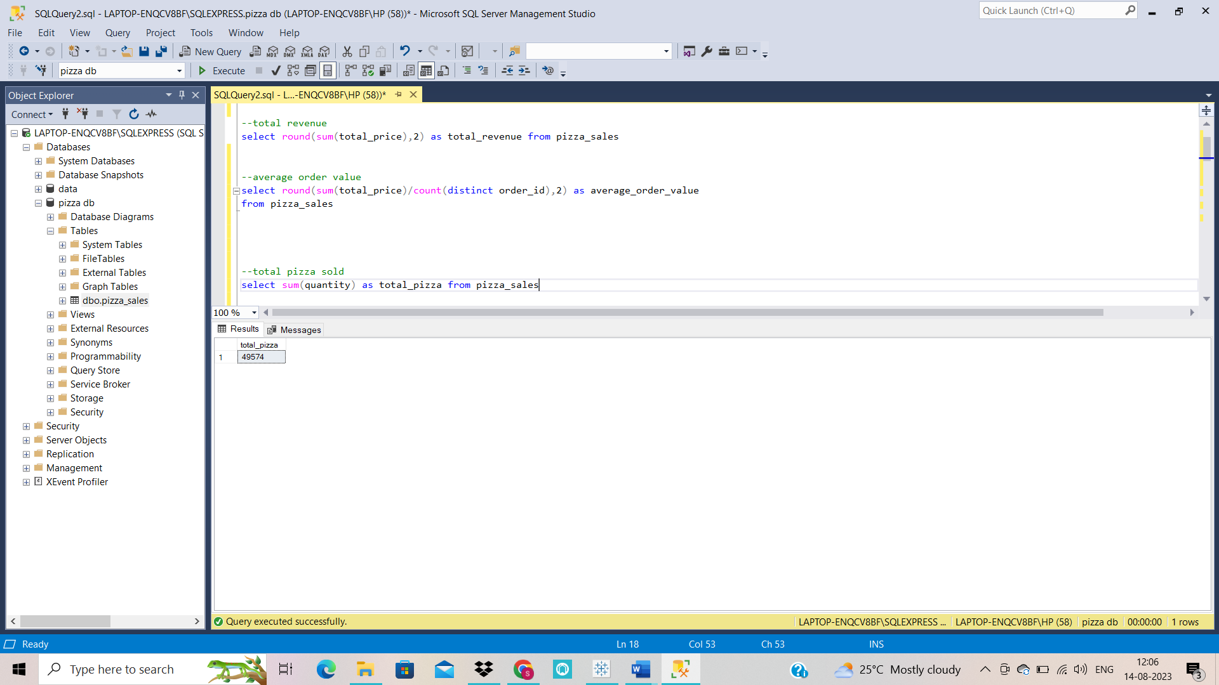

* 1. **Total Orders**

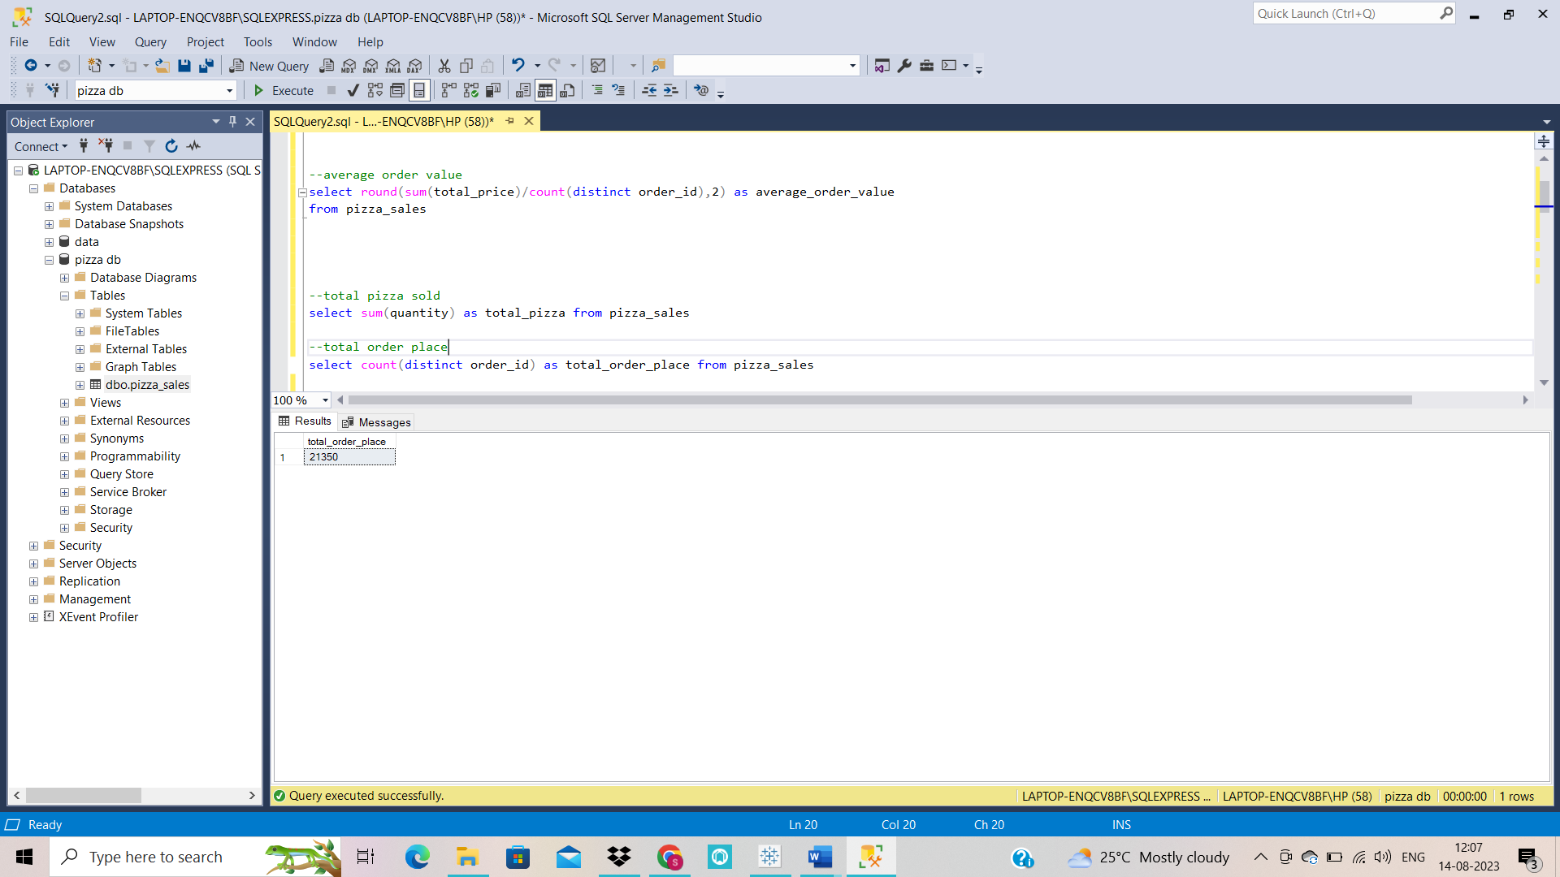

* 1. **Average Pizzas Per Order**

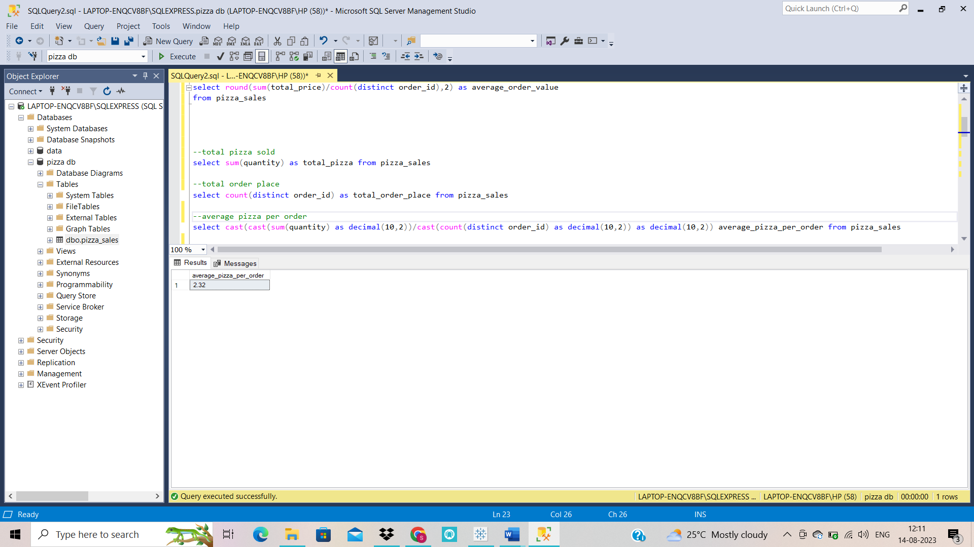

1. **Daily Trend for Total Orders**

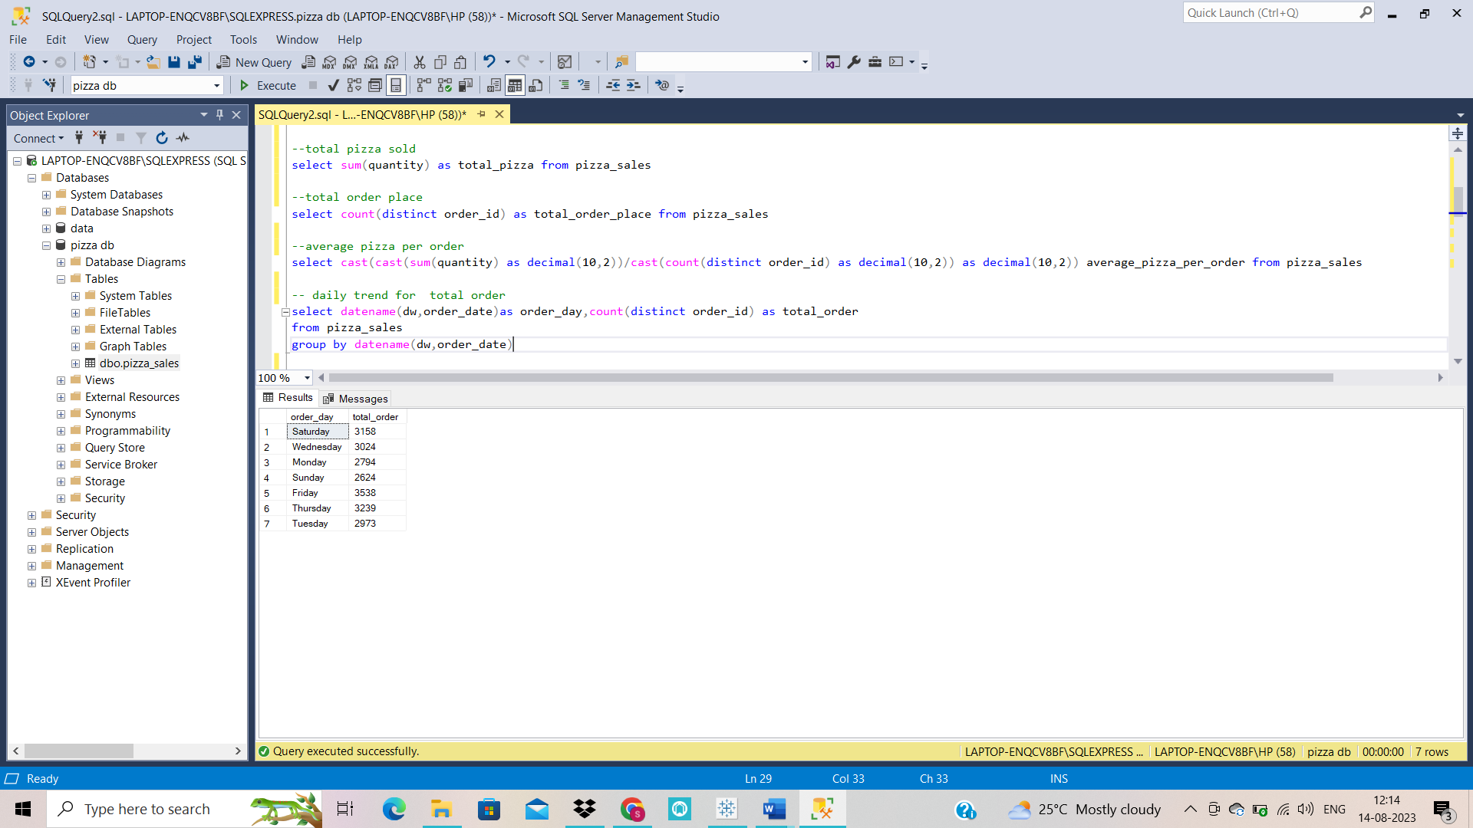

1. **Monthly Trend for Orders**

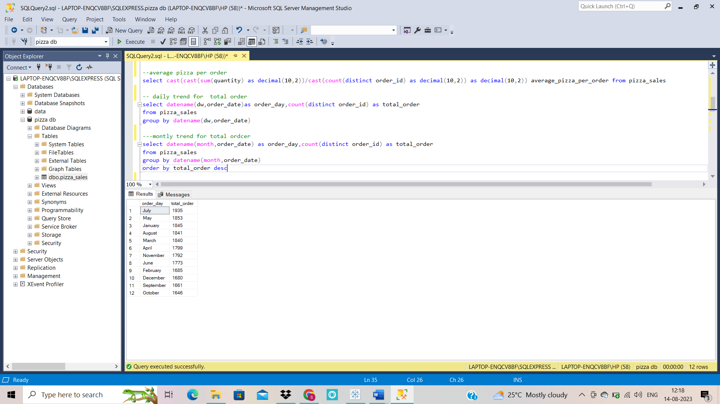

1. **% of Sales by Pizza Category**

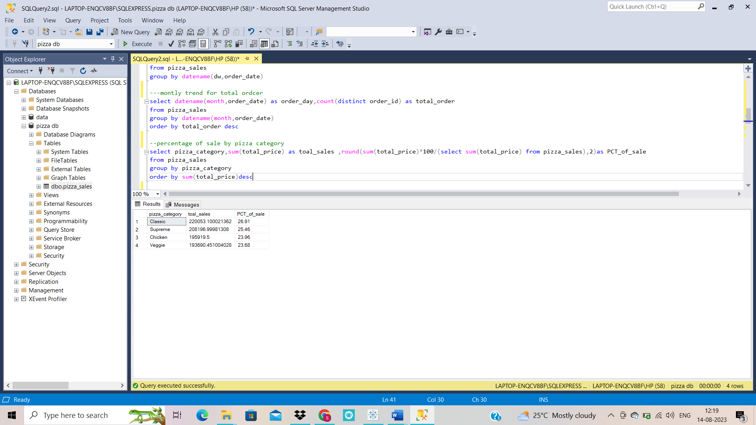

1. **% of Sales by Pizza Size**

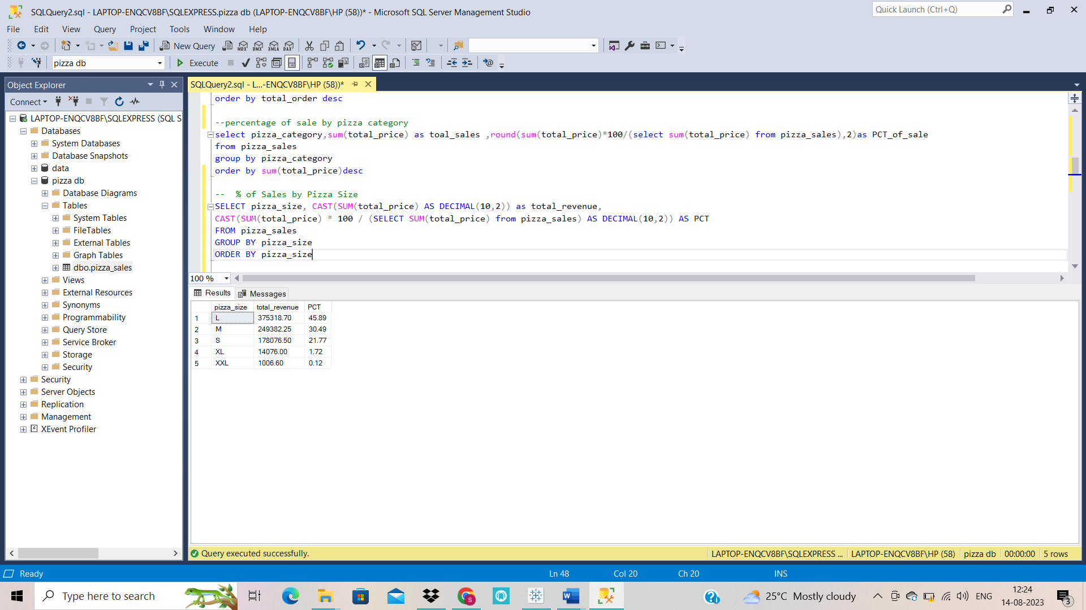

1. **Total Pizzas Sold by Pizza Category**

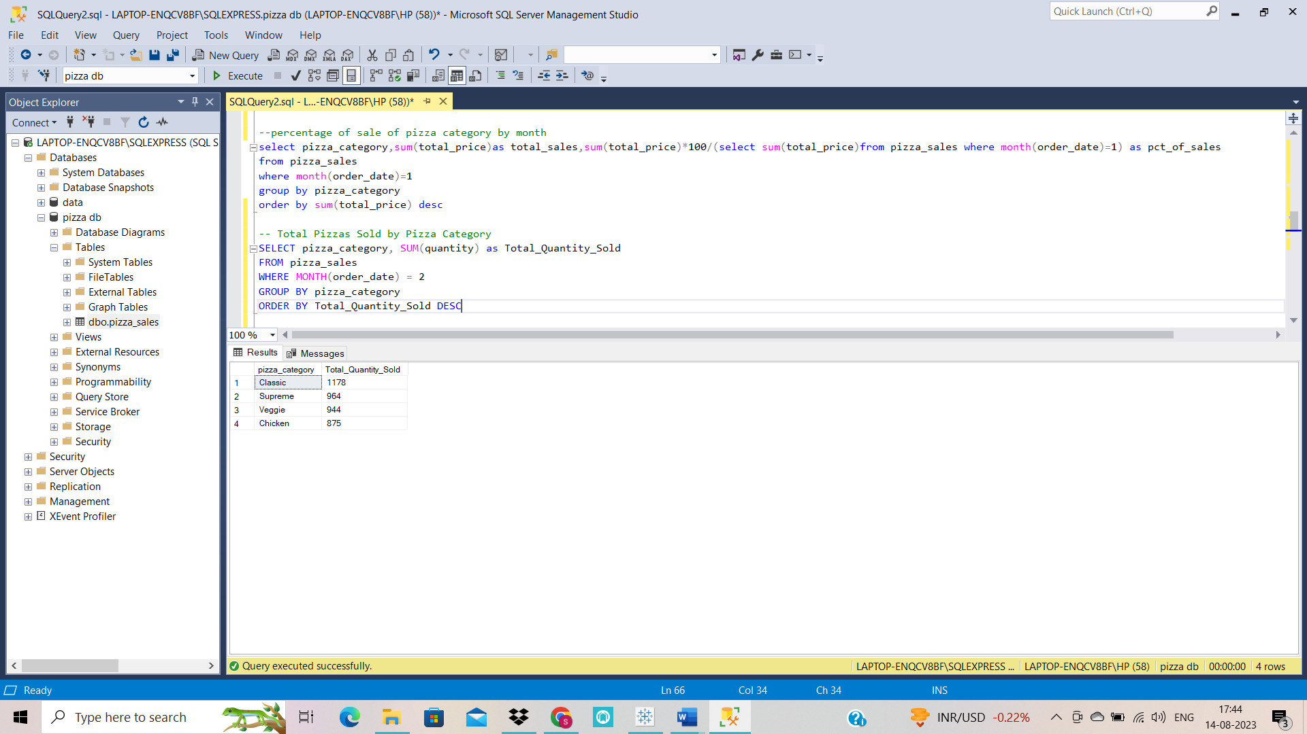

1. **percentage of sales of pizza category by month**

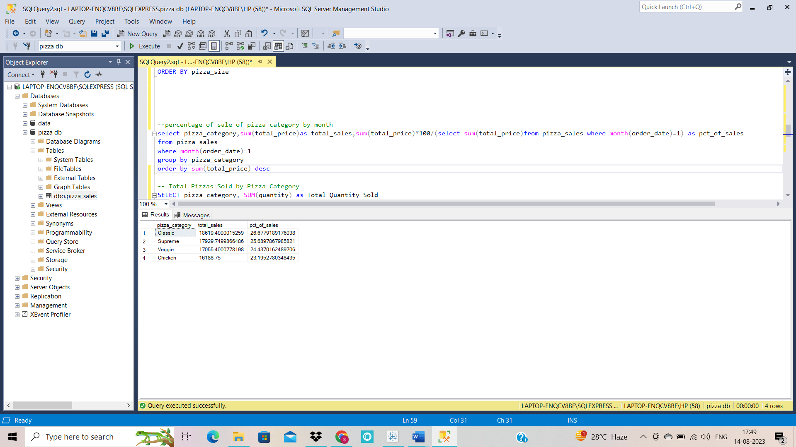

1. **Percentage of sale by pizza category (SIZE)**

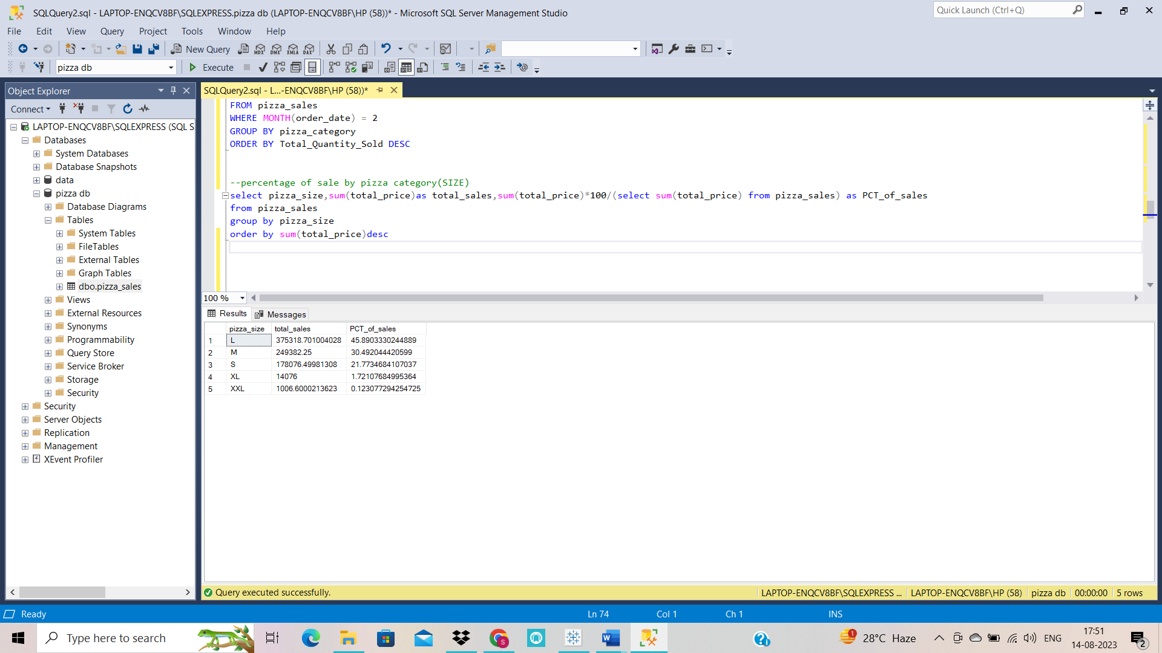

1. **Percentage of sale of pizza category by quarter**

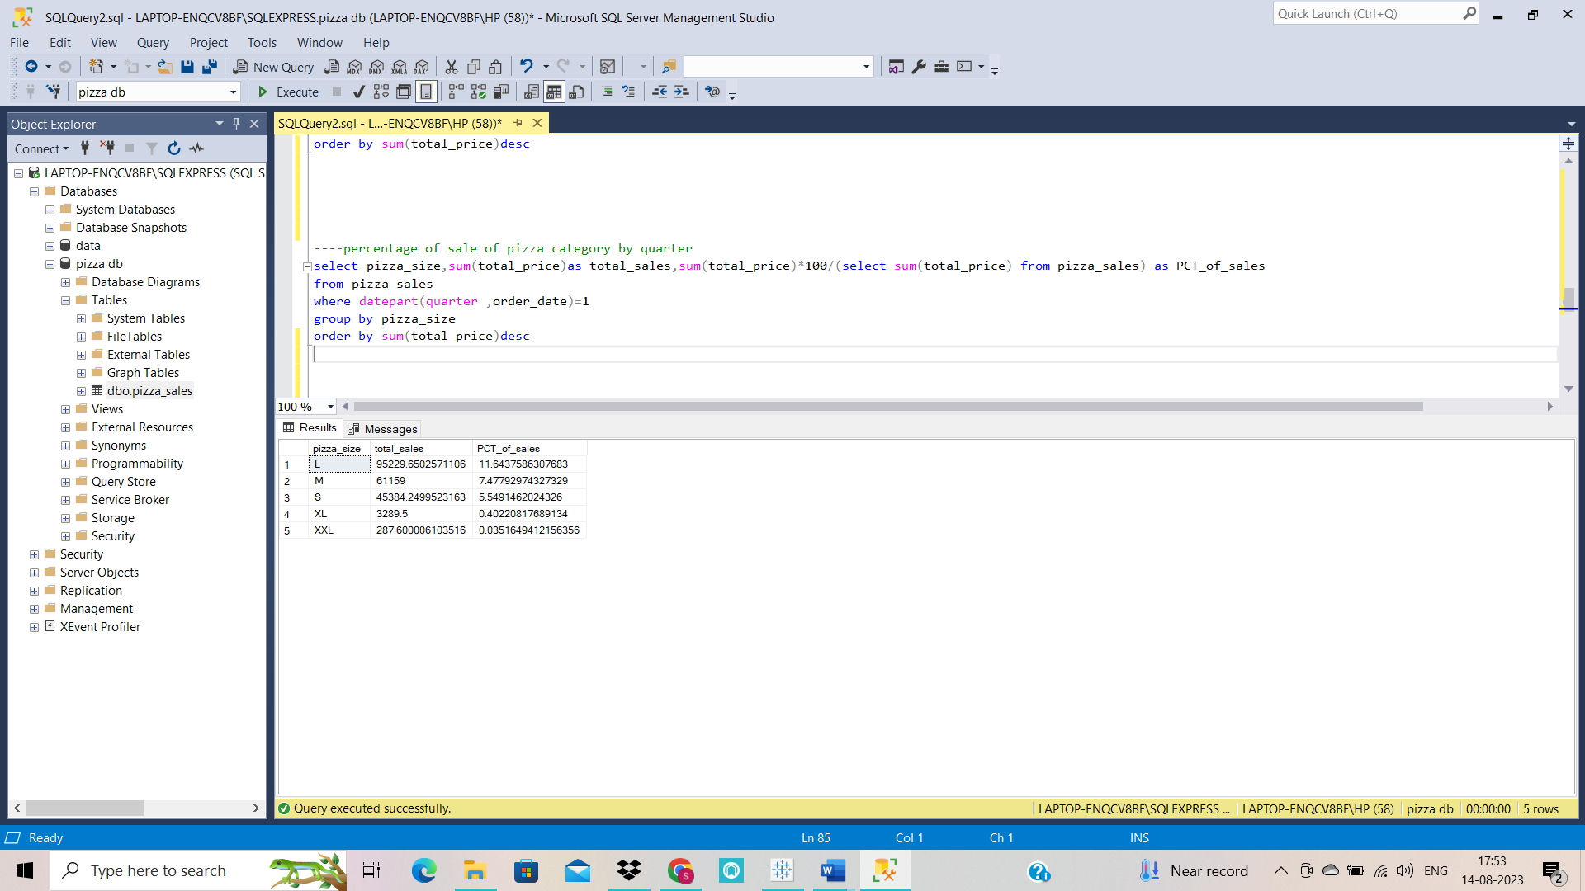

1. **Top 5 Pizzas by Revenue**

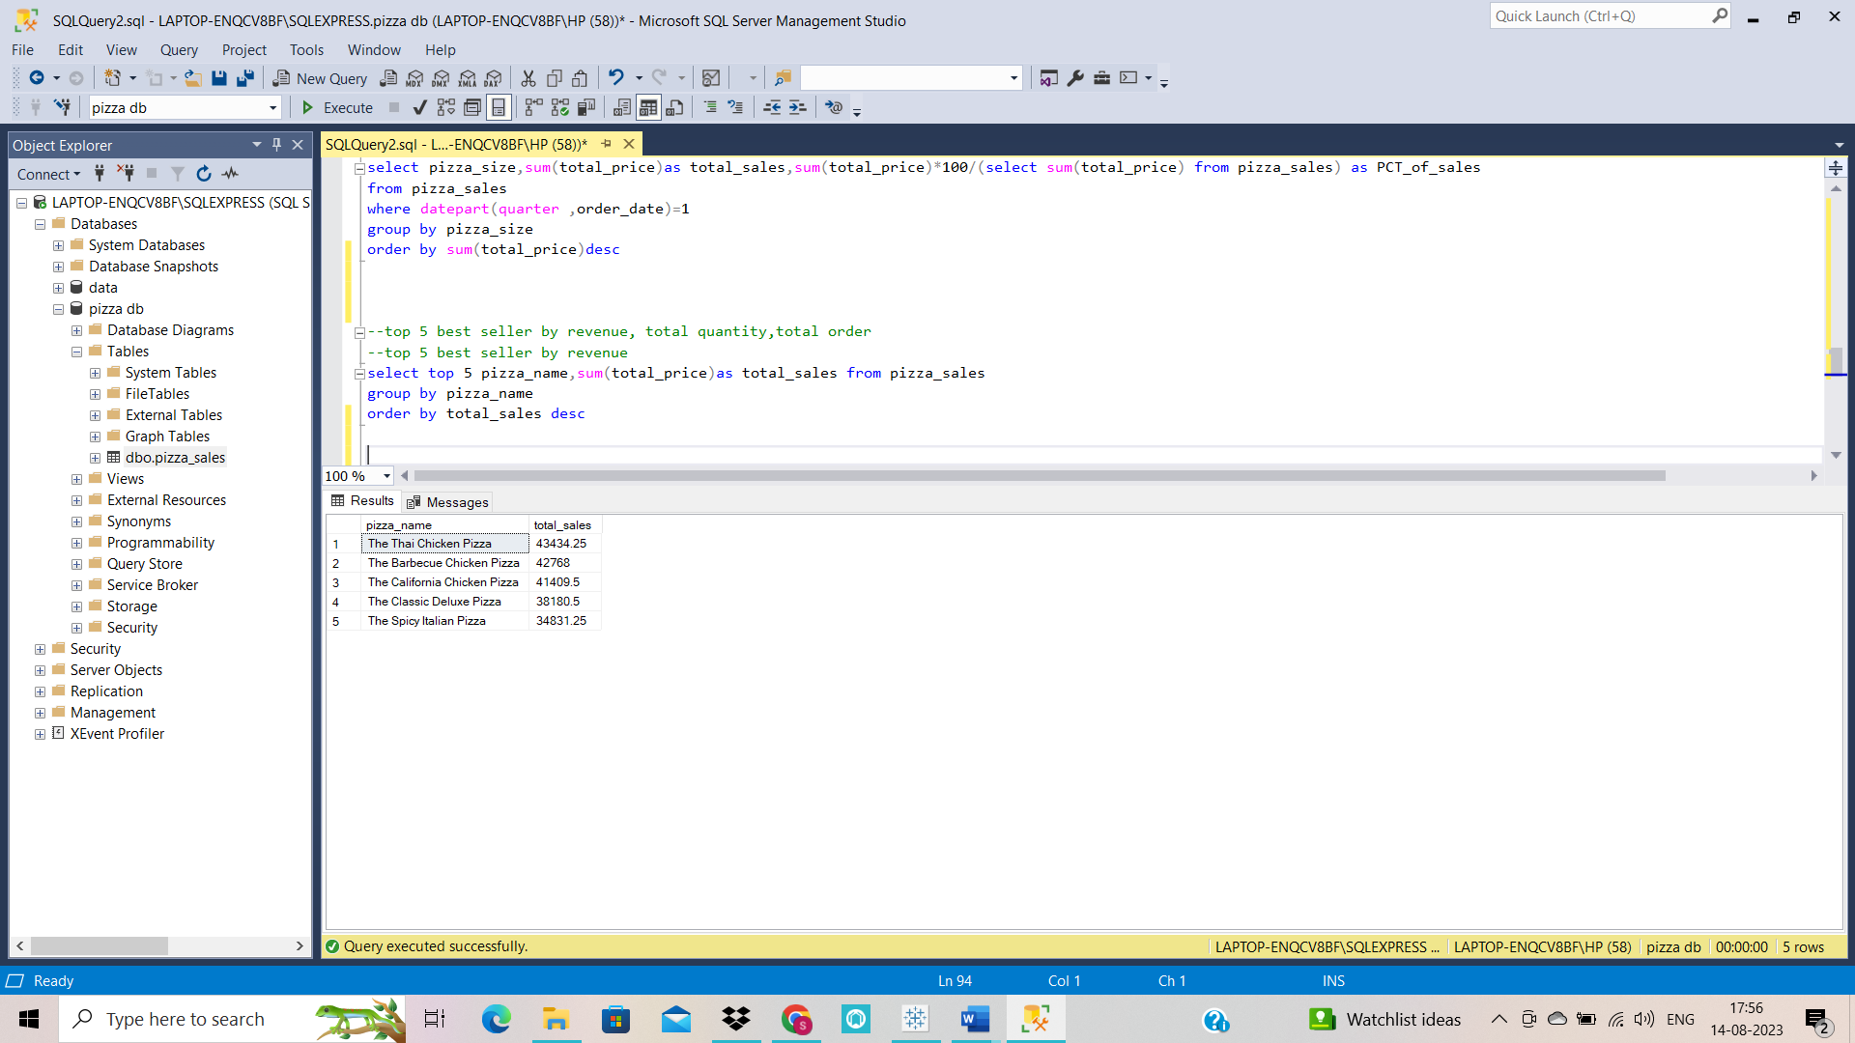

1. **Bottom 5 Pizzas by Revenue**

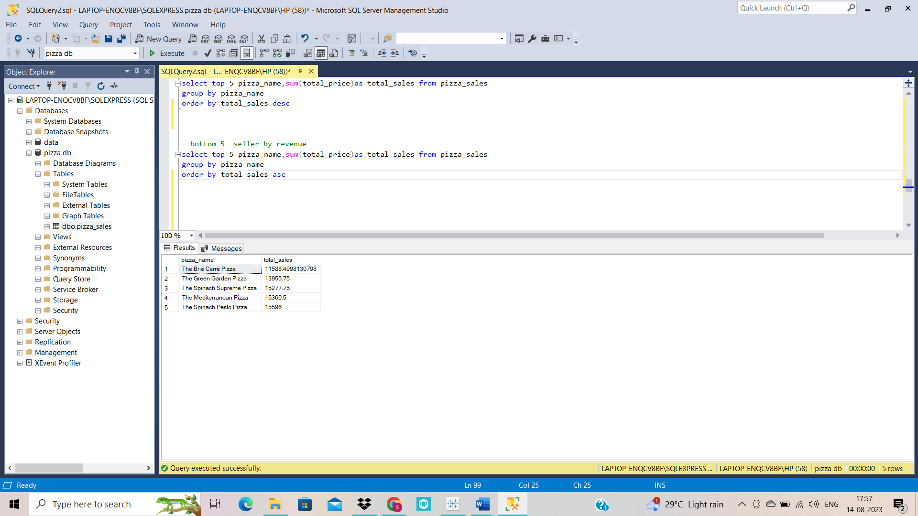

1. **Top 5 Pizzas by Quantity**

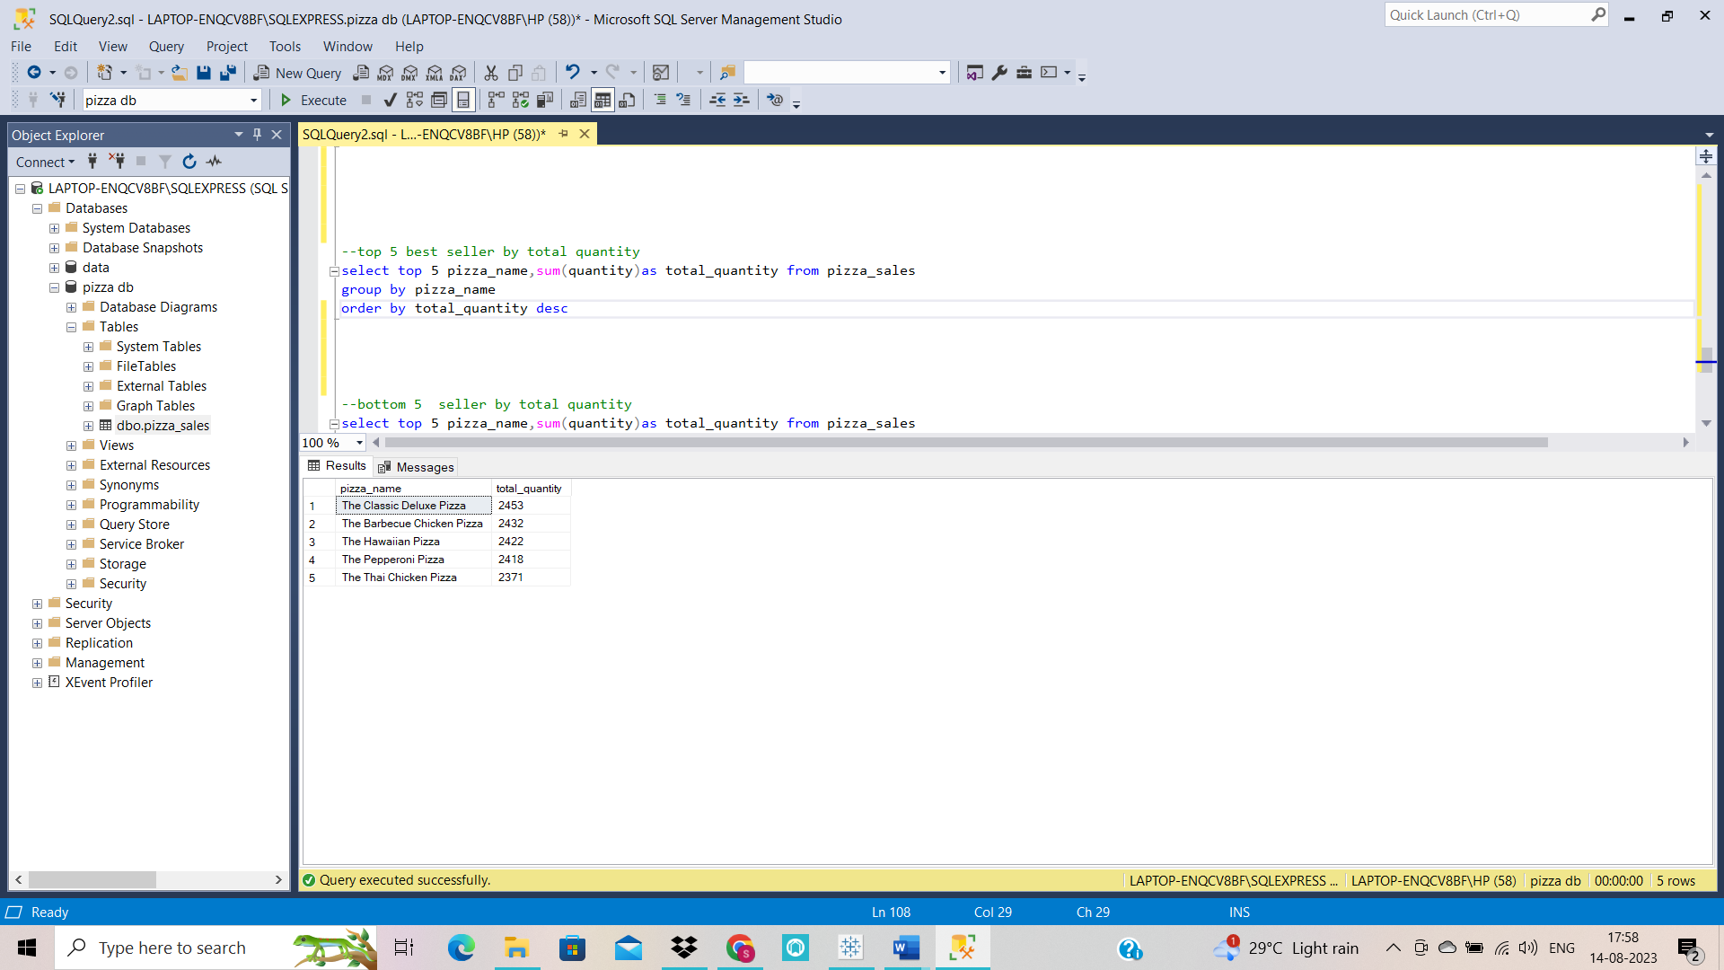

1. **Bottom 5 Pizzas by Quantity**

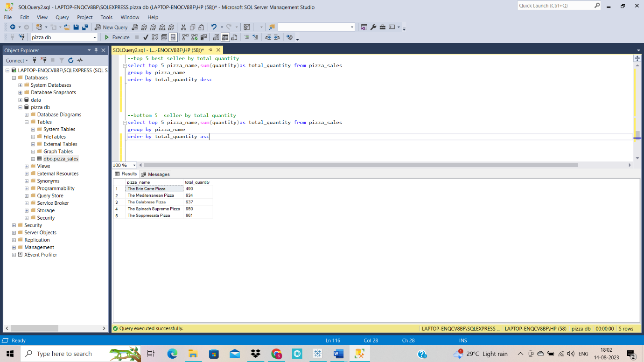

1. **Top 5 Pizzas by Total Orders**

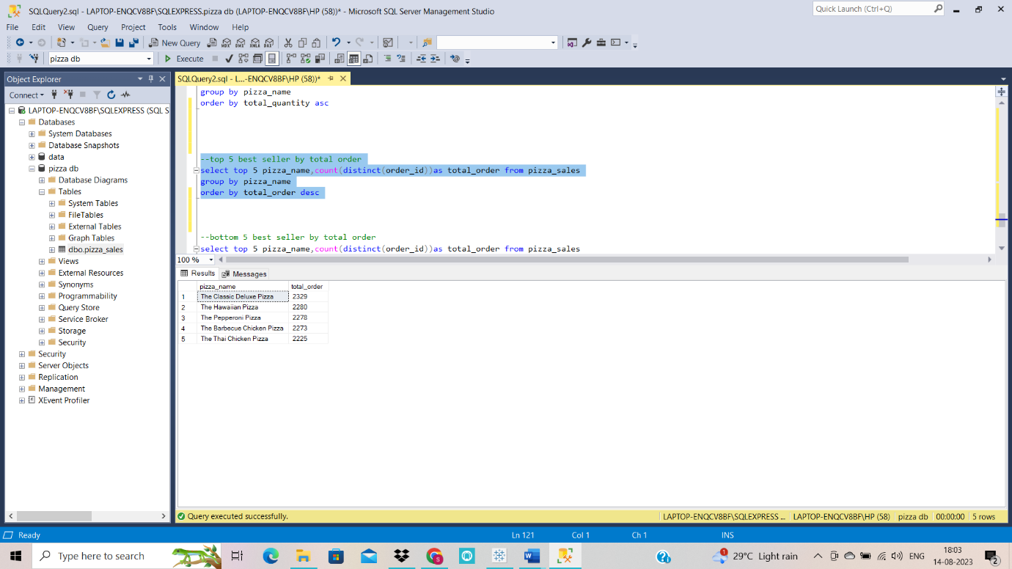

1. **Bottom 5 Pizzas by Total Orders**

